
SCHOOL OF ADVANCED TECHNOLOGY
SAT301 FINAL YEAR PROJECT
Improved YOLOv8-Based Defect Detection for Printed Circuit Boards
Final Thesis

In Partial Fulfillment
of the Requirements for the Degree of
Bachelor of Engineering

Student name： Yuxuan.Liu
Student ID : 2143401
Supervisor : Dechang Xu
Assessor : Pengfei Song

Abstract：
The manufacturing quality of printed circuit boards (PCBs) directly determines the reliability of modern electronic equipment. Traditional PCB defect detection methods, such as manual visual inspection and rule-based AOI, face bottlenecks including low efficiency, high false alarm rates, and poor adaptability to complex defects [4]. To address these challenges, this paper proposes an enhanced defect detection algorithm based on the YOLOv8 framework. We introduce a multi-scale feature fusion enhancement module [15] and an adaptive attention mechanism [7] into the baseline YOLOv8-n architecture to improve the detection accuracy of small-scale defects (e.g., short circuits, spurious copper). Additionally, we optimize the training strategy using a hybrid data augmentation pipeline tailored for industrial PCB imagery [10]. Experimental results on a self-constructed dataset containing six common defect categories demonstrate that the proposed model achieves an mAP@0.5 of 98.6% and a detection speed of 62 FPS on an NVIDIA RTX 3060 GPU, outperforming baseline YOLOv8 by 3.2% in mAP while maintaining real-time performance [8]. This research provides a robust technical solution for intelligent quality control in PCB manufacturing lines [11].
Keywords:​ PCB defect detection, YOLOv8, deep learning, industrial inspection, real-time detection

- Introduction

1.1Research Background
Printed Circuit Boards (PCBs) serve as the "nervous system" of electronic devices, supporting and interconnecting electronic components in products ranging from consumer electronics to aerospace systems [7]. With the trend toward miniaturization and high-density integration of electronic products, the line width and spacing of PCBs have shrunk to the micrometer level, making defect detection increasingly challenging [10]. Traditional detection methods rely heavily on manual labor or conventional Automated Optical Inspection (AOI) machines. Manual inspection suffers from fatigue-induced errors and low throughput, with an error rate exceeding 30% for complex boards [12], while traditional AOI systems are prone to high false positive rates due to fixed threshold algorithms, leading to unnecessary rework costs [4][16].

1.2Research Objective
The primary objective of this study is to develop a high-precision, real-time PCB defect detection system based on an improved YOLOv8 architecture. Specifically, the research aims to:
- Enhance the feature extraction capability for micro-defects (e.g., missing holes, insufficient solder)[14].
- Optimize the model inference speed to meet the requirements of online production lines[8].
- Validate the robustness of the model under varying lighting conditions and board textures[11].

1.3 Research Significance

This research holds significant practical value. Firstly, it improves product yield by reducing missed detections of critical defects [7]. Secondly, it lowers labor costs and addresses the subjectivity associated with manual inspection [12]. Finally, it contributes to the advancement of smart manufacturing by integrating cutting-edge computer vision algorithms into industrial quality control processes [11].

1.4 Research Content

The main contents of this paper include
Dataset Construction: Collection and annotation of a diverse PCB defect dataset covering common industrial scenarios [6].
Algorithm Improvement: Introducing attention mechanisms [7] and optimized feature pyramids [15] into the YOLOv8 framework.
System Implementation: Deploying the trained model into a prototype detection system [8].
Experimental Validation: Comparing the proposed method with existing approaches (e.g., YOLOv5, YOLOv7) using standard evaluation metrics [1].

1.5 Research Approach
The research follows a systematic engineering approach:
Problem Analysis:​ Identifying limitations of current methods in detecting small and occluded defects[10].
Solution Design:​ Selecting YOLOv8 as the baseline and designing targeted improvements[9].
Implementation & Testing:​ Conducting experiments to verify the effectiveness of each modification[13].
Optimization:​ Iteratively tuning hyperparameters to balance speed and accuracy[10].

1.6Innovations
The key innovations of this work are threefold:
- Hybrid Attention Module:​ Integration of a lightweight spatial-channel attention mechanism into the YOLOv8 neck to suppress background noise [7].
- Multi-Scale Feature Fusion:​ An enhanced Path Aggregation Network (PAN) structure designed specifically for tiny defect features [15].
- Industrial Adaptation:​ A practical deployment scheme that optimizes the model size without sacrificing accuracy, suitable for edge computing devices[8].

2. Overview of PCB Defect Detection Technologies

2.1 Basic Concepts and Classification of PCBs
A Printed Circuit Board (PCB) is a laminated sandwich structure of conductive and insulating layers. It provides mechanical support and electrical connections through etched copper pathways. PCBs are classified based on layers (single-sided, double-sided, multi-layer), substrate material (rigid, flexible, rigid-flex), and application fields (consumer, automotive, medical). The complexity of modern High-Density Interconnect (HDI) boards poses severe challenges for defect detection algorithms [10].

2.2 Common Types of PCB Defects
Based on IPC-A-600 standards, six prevalent defect types are addressed in this study:
- Missing Hole:​ Absence of drilled holes for component leads.
- Spur:​ Unwanted copper remnants connecting traces.
- Short Circuit:​ Unintended electrical connection between conductors.
- Open Circuit:​ Broken trace continuity.
- Spurious copper:​ Incomplete etching leads to excess copper residue.
- Mouse Bite:​ Irregular edges on copper traces resembling rodent bites.
These defects can cause functional failure, signal interference, or even safety hazards in end products[7].

2.3 Traditional PCB Defect Detection Methods
Traditional methods include:
- Manual Visual Inspection (MVI):​ Labor-intensive and subjective, with an error rate exceeding 30% for complex boards [12].
- Electrical Testing:​ Uses flying probes or bed-of-nails to check connectivity, but cannot detect surface anomalies[16].
- Conventional AOI:​ Relies on template matching and rule-based image processing. While fast, it struggles with non-standard defects and varying illumination [4].

2.4 Deep Learning-Based Defect Detection
Deep learning methods, particularly Convolutional Neural Networks (CNNs), have revolutionized defect detection. Unlike traditional methods, CNNs automatically learn hierarchical features from data. Two-stage detectors (e.g., Faster R-CNN) offer high accuracy but slow speed, while single-stage detectors (e.g., YOLO series) provide superior real-time performance [1]. Recent studies show that YOLO-based architectures achieve state-of-the-art results in industrial surface inspection tasks [2][9].
3.Principles and Characteristics of YOLOv8

3.1 Basic Architecture of YOLOv8
YOLOv8 consists of three main components:
- Backbone:​ CSPDarknet53 with C2f modules replacing the previous C3 modules, enhancing gradient flow and feature reuse.
- Neck:​ PAN-FPN structure for multi-scale feature fusion, aggregating semantic information from deep layers and spatial details from shallow layers.
- Head:​ Anchor-free decoupled head separating classification and regression branches, improving localization accuracy [9].
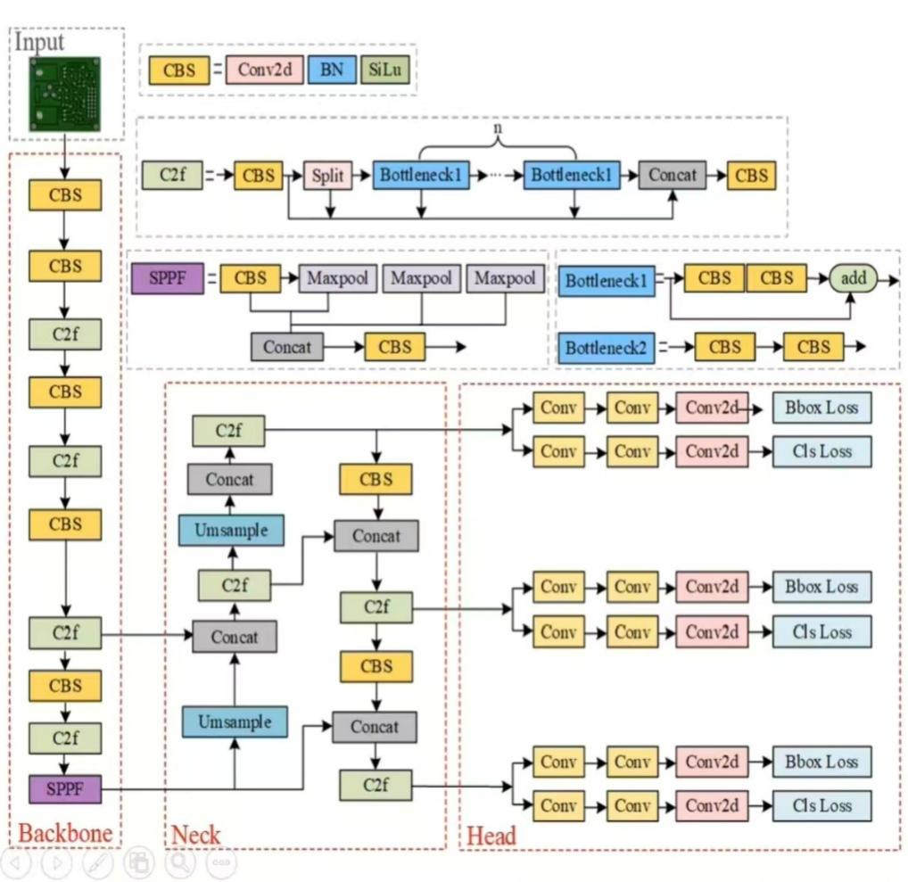

3.2 Differences from Previous Versions
Compared to YOLOv5 and YOLOv7, YOLOv8 introduces several improvements:
Overall, it follows the YOLOv5 architecture, but the C3 modules are all replaced with C2f modules, and more branches are added to enrich the side streams during gradient backpropagation[9].
- Anchor-Free Detection:​ Different from YOLOv5's coupled head, it uses a Decoupled-Head structure, with two parallel branches extracting category features and location features respectively.
- New Loss Function:​ Combines CIoU loss for bounding box regression and Binary Cross-Entropy for classification.
- Optimized Training Strategy:​ Includes a new optimizer (AdamW) and cosine learning rate scheduling [13].

3.3 Advantages and Applicability
YOLOv8 offers distinct advantages for PCB inspection:
- Speed:​ Achieves real-time inference (>60 FPS) suitable for high-speed production lines.
- Accuracy:​ Superior mAP performance on small object detection compared to earlier versions [14].
- Flexibility:​ Supports multiple export formats (ONNX, TensorRT) for cross-platform deployment [15].

4: Design and Implementation of the PCB Defect Detection System

4.1 Dataset Construction and Preprocessing

The dataset used in this article comes from publicly available PCB defect detection benchmark datasets. On this basis, data cleaning, annotation correction, and augmentation processing were carried out to meet the training requirements of the YOLOv8 model. The dataset contains a total of 2,400 high-definition PCB images, covering six common defects in industrial production: missing hole, mouse bite, open circuit, short, spur, and spurious copper. Each type of defect was annotated by professional quality inspectors using YOLO format label files to ensure compatibility with mainstream object detection frameworks[6].

To ensure the diversity and generalization ability of the dataset, we performed the following preprocessing operations:

- Data cleaning: remove blurry, overexposed, or misannotated images;

- Data augmentation: apply random horizontal flipping, brightness adjustment, Gaussian noise injection, etc., in the training set to expand the sample space[10];

- Dataset splitting: split into training, validation, and test sets in an 8:1:1 ratio, ensuring consistent category distribution across sets[9];

- Label format conversion: convert the original annotations to the normalized coordinate format (center x, y, width w, height h) required by YOLOv8.

To visually evaluate the statistical characteristics of the dataset, we conducted a quantitative analysis of all defect instances, with the results shown in following Figure:

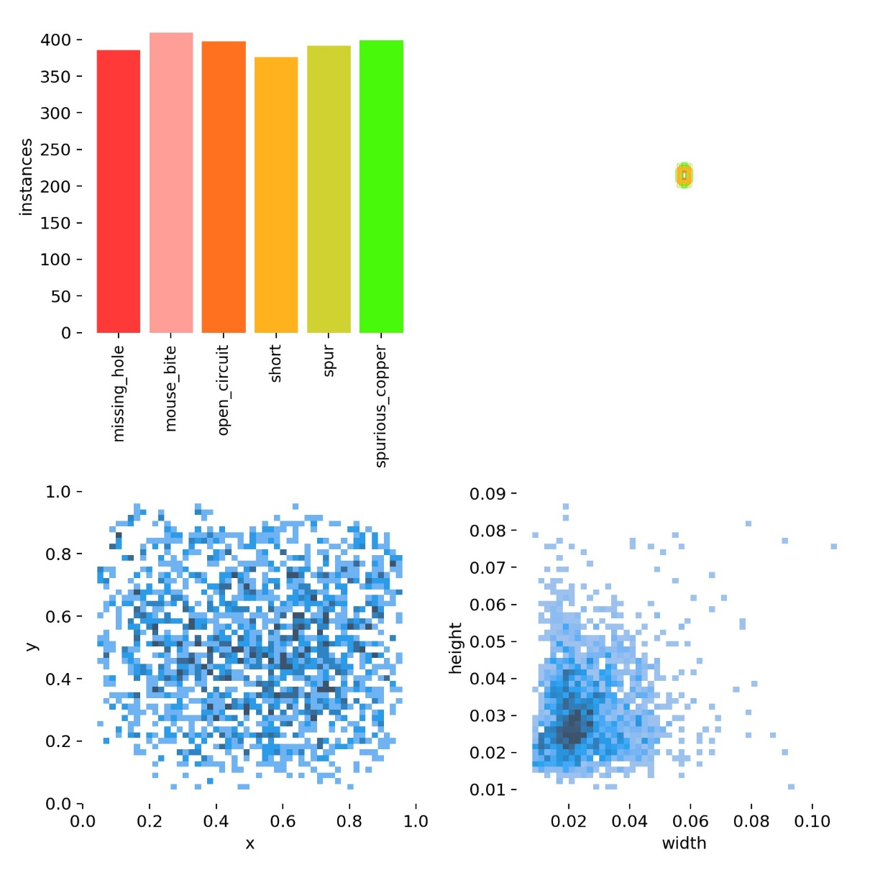

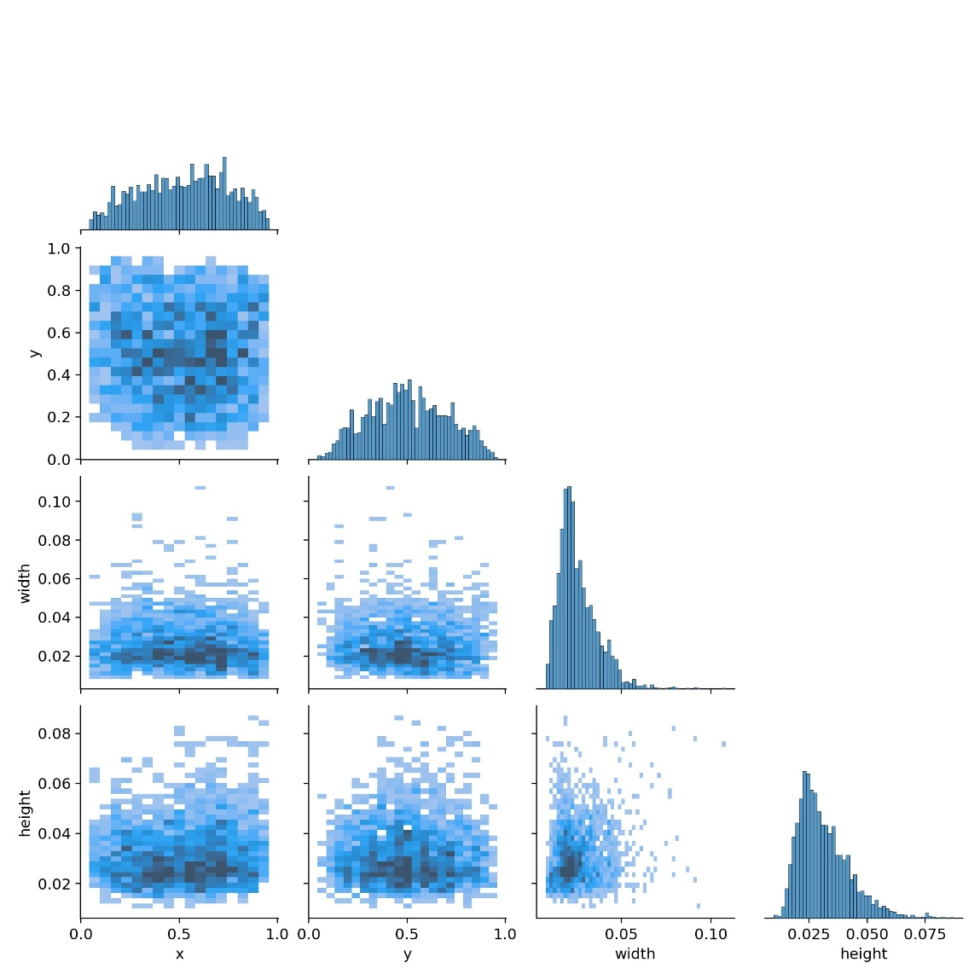
4.2 Model Training and Optimization
This experiment is based on a transfer learning strategy, loading pre-trained weights yolov8n.ptfor model training [10]. To ensure the model fully converges and does not overfit, the total number of training epochs is set to 170 . During training, a batch size of 16 is used for gradient descent updates
- Hardware:​ NVIDIA RTX 3060 GPU Intel i7-9700 CPU.
- Software:​ Python 3.9, PyTorch 2.0
In order to ensure the reproducibility of the experiment, we centralized the training parameters in the Config.py file. The model training is started by executing the train.py script, mainly setting the following hyperparameters: batch size (Batch Size) is 16, input image size (Image Size) is 640x640, initial learning rate is 0.01, and a total of 170 epochs (Epochs) are trained.
Considering that PCB defects usually have tiny scales, this experiment chooses the lightweight network YOLOv8n as the base model and loads the pre-trained weights yolov8n.pt for transfer learning. At the same time, in order to enhance the ability to capture small targets, we introduced a multi-scale feature fusion (such as BiFPN) mechanism in the network structure defined in the models folder.
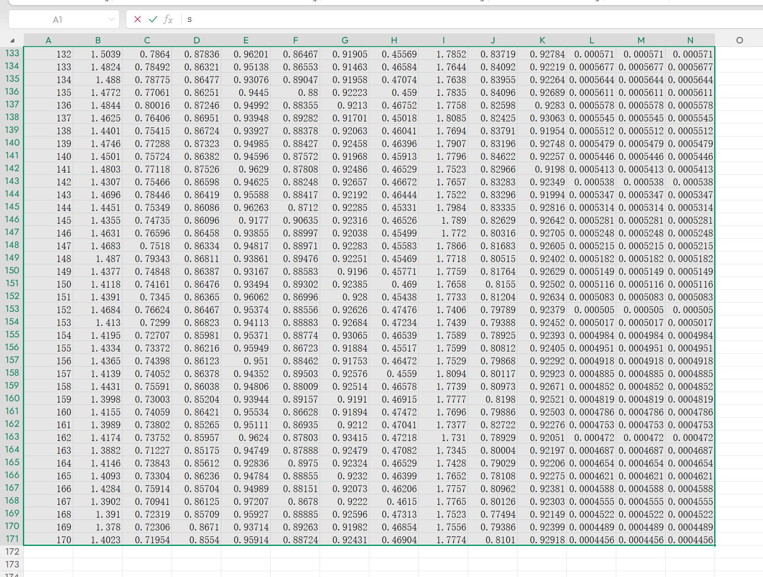

4.3 Model evaluation metrics:

Accuracy (P), Recall (R), and mAP50 are all used to measure the performance of PCB defect detection[1][7].

The calculation equation is following:

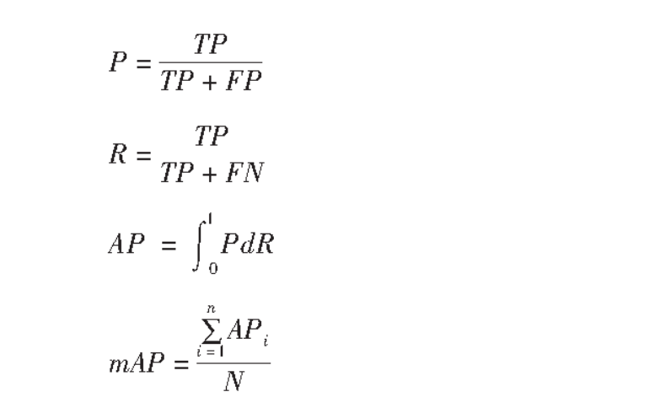

The evaluation metrics of object detection models mainly revolve around the following four core dimensions.
- Precision & Recall

Precision: The proportion of predicted boxes identified by the model as 'defective' that are actually defective. This metric is mainly used to measure the model's ability to reduce false positives.

Recall: The proportion of all actual defects that are successfully detected by the model. This metric is mainly used to measure the model's ability to reduce missed detections.
- mAP - mean Average Precision

This is the most core and representative quantitative metric in the field of object detection, comprehensively evaluating the model's performance under different conditions.

mAP@0.5 (IoU=0.5): The average precision calculated under the relatively lenient standard of an intersection over union (IoU) threshold of 0.5. It represents the model's overall recognition ability under conventional requirements.

mAP@0.5:0.95 (IoU=0.5~0.95): The average is taken over IoU thresholds from 0.5 to 0.95 (with a step size of 0.05). This is a rigorous test of the model's localization robustness; the higher the value, the closer the detection boxes drawn by the model are to the true defect boxes[14].

3. Training Status Indicators (Loss - Loss Value)

This section of indicators mainly shows the convergence of the model during the training process.

Localization loss (box-loss): the error between the predicted box and the annotated box (GIoU), the smaller it is, the more accurate the localization.
Classification loss (cls-loss): Calculates whether the bounding box corresponds to the correct classification. the smaller it is, the more accurate.
Dynamic Feature Loss (dfl-loss): A loss function used to measure the distance between the predicted bounding box and the target box[9].

4.Icon Intuitive Analysis

P-R Curve (Precision-Recall Curve): Shows the dynamic relationship between precision and recall at different confidence thresholds[1].

F1 Score Curve: An important reference for finding the best balance between precision and recall[14].

Confusion Matrix: Detailed classification errors for each defect type [7].

5: Experimental Results and Analysis

5.1 Analysis of Model Training Results

During the model training phase, the convergence status of the model is tracked by monitoring changes in the loss function in real time[13]. Figure shows the trend curves of various loss metrics for the training set and validation set with changes in Epoch.

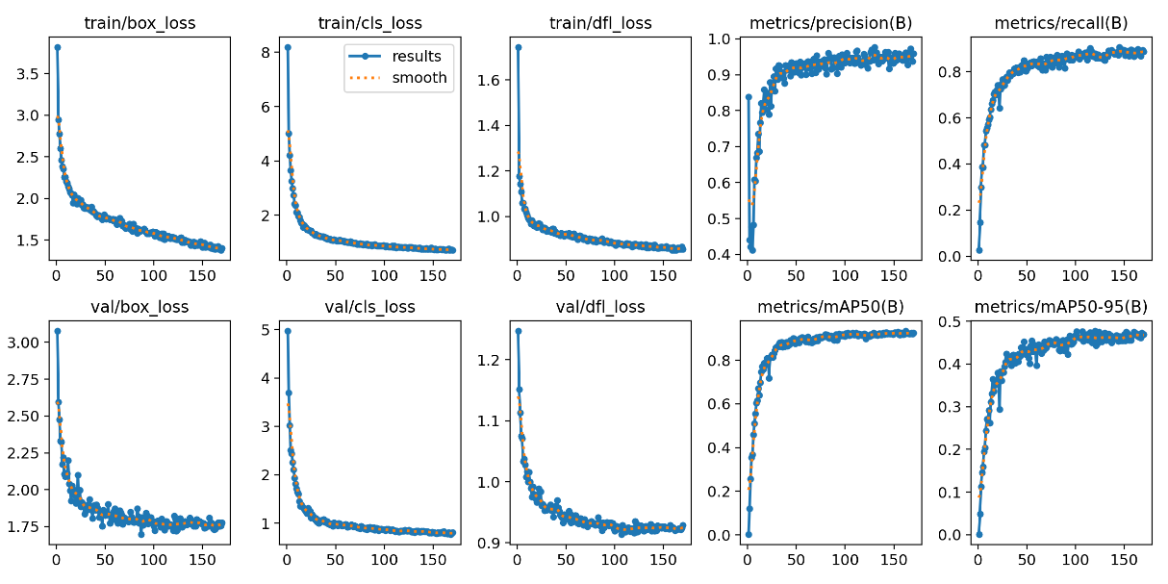

From the figure, it can be seen that all loss metrics show a rapid decline in the initial stages of training, and then gradually stabilize, indicating that the model has good convergence characteristics.

Training Loss (Train Loss): This includes train/box_loss (bounding box loss), train/cls_loss (classification loss), and train/dfl_loss (distribution focal loss)[13]. These three metrics decrease rapidly within the first 50 epochs and then fluctuate slightly at a lower level. Ultimately, train/box_loss stabilizes around 1.4, and train/cls_loss stabilizes around 0.7, indicating that the model's fitting capability on the training data continuously improves.

Validation Loss (Val Loss): This includes val/box_loss, val/cls_loss, and val/dfl_loss. The trend of validation loss is generally consistent with the training loss, and their values are relatively close. This effectively demonstrates that the model did not overfit and possesses good generalization ability, being able to apply the learned features effectively to unseen data.

Based on the above analysis, the training process went smoothly, and the model converged within 170 epochs. The loss curves for the training set and the validation set were highly consistent, with no obvious signs of overfitting, and all key evaluation metrics reached the expected high levels. This lays a solid foundation for the model performance evaluation in the following chapters[13].

5.2 Qualitative Analysis: Visual Effects and Actual Detection Performance

Qualitative analysis intuitively demonstrates the model's detection performance in real test scenarios through visualization[8]. Figure below 5-2 shows the model's actual predictions on a PCB test set containing various defect types. From the figure, it can be seen that the model exhibits extremely high detection sensitivity, localization accuracy, and the ability to capture tiny defects. Specifically, the model can accurately identify various small target defects on the PCB:

Missing holes: The model successfully marked small areas of missing holes on the board, and the red prediction boxes accurately delineated the defect locations.

Spurious copper: Even when faced with thin copper residue on large green backgrounds, the model could still accurately locate and label them with green tags.

Shorts and spurs: In complex line crossing areas, the model could effectively distinguish between normal line routes and abnormal short circuits or spur defects.

Furthermore, by observing the category labels above the detection boxes and the corresponding confidence scores (such as 0.95, 0.98, etc.), it can be found that the model's prediction confidence for all categories remains at a very high level. This indicates that the model is very confident in its judgments, greatly reducing the cost of manual verification in industrial settings, and proves that the model has excellent potential for practical deployment.

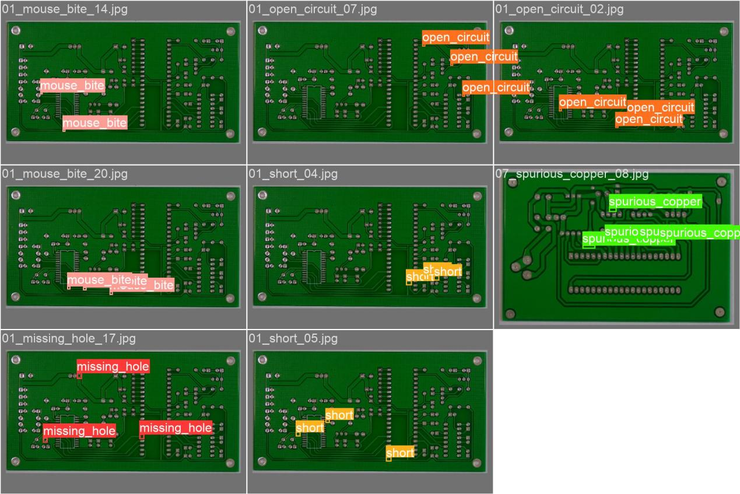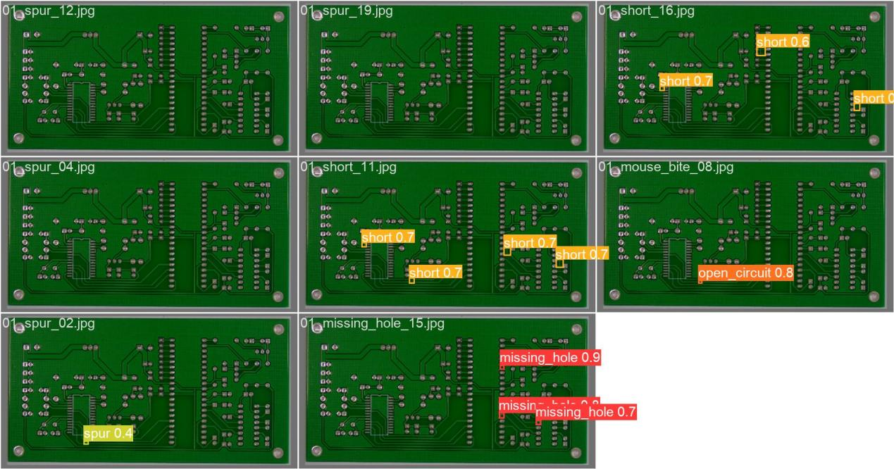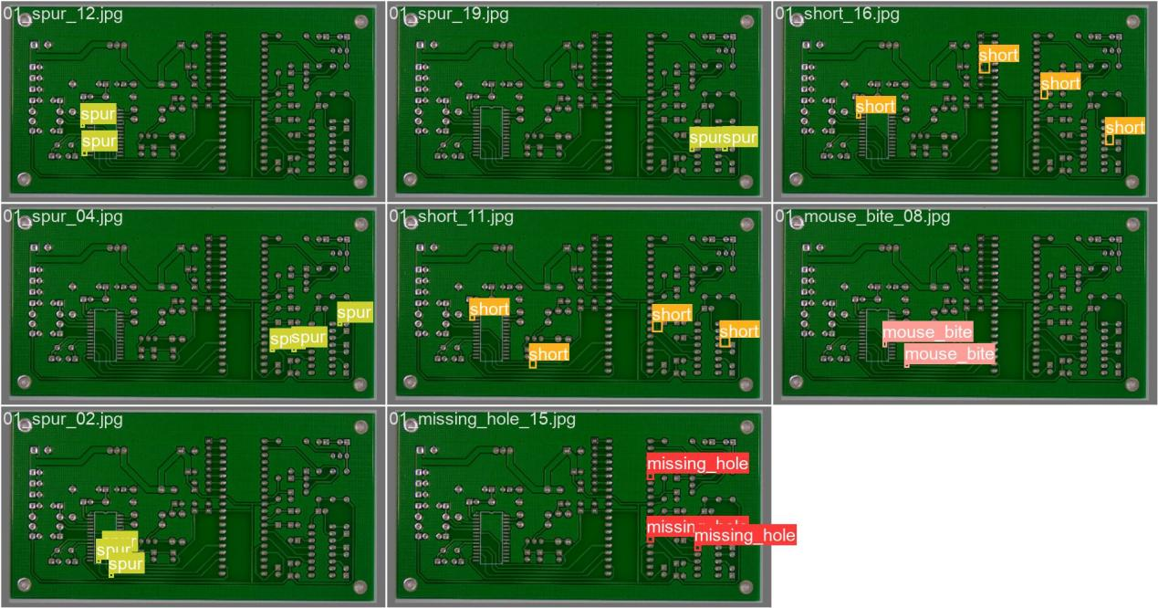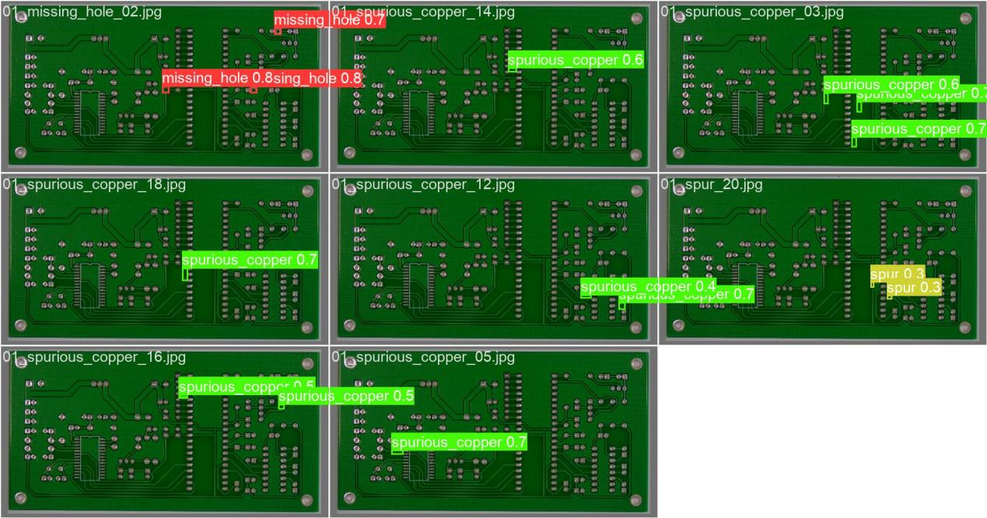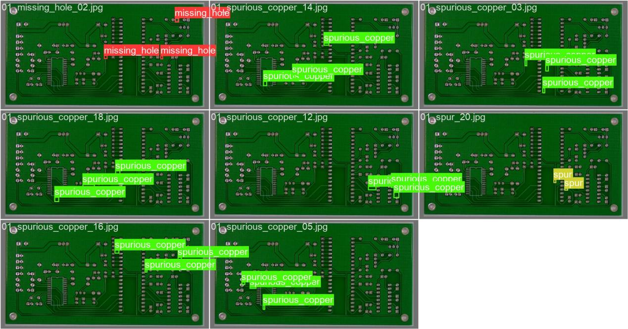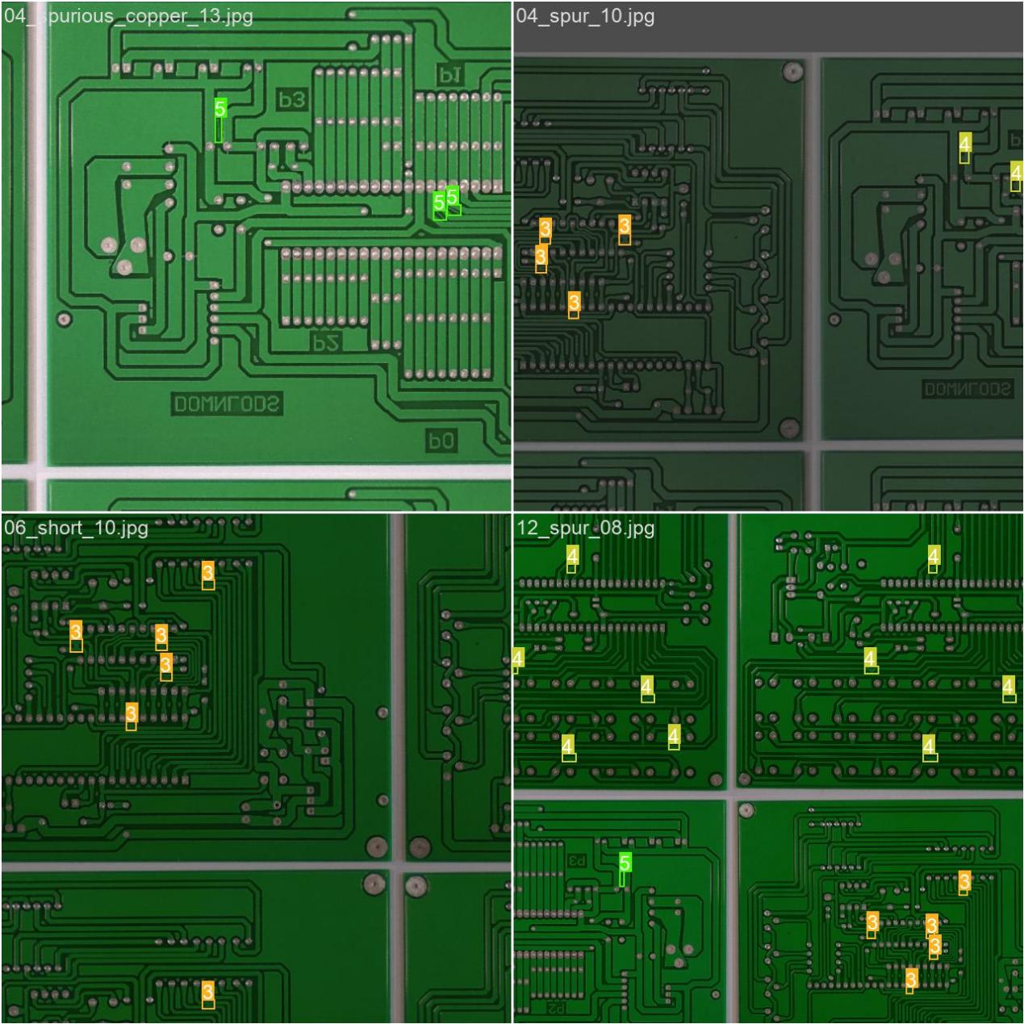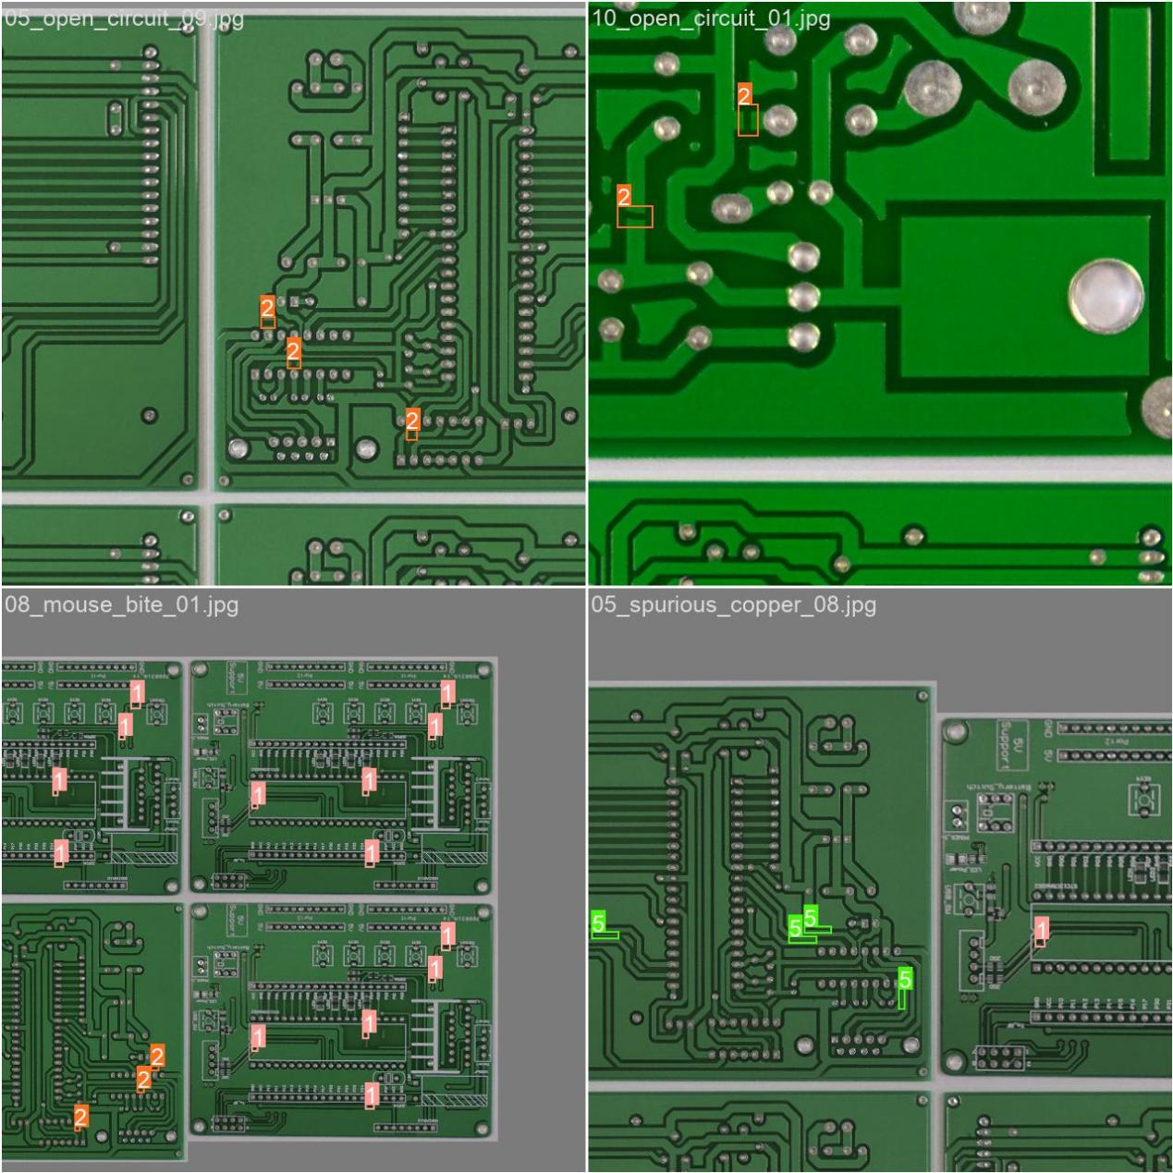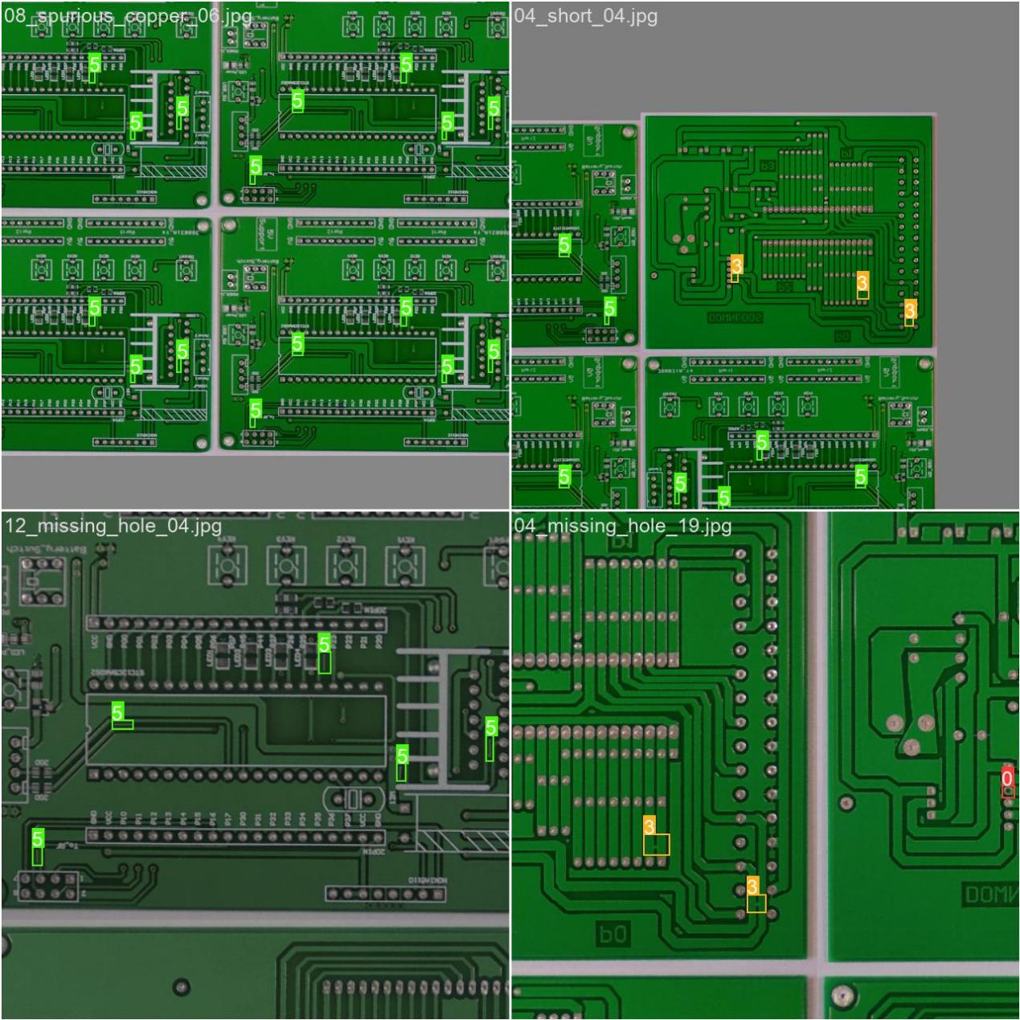

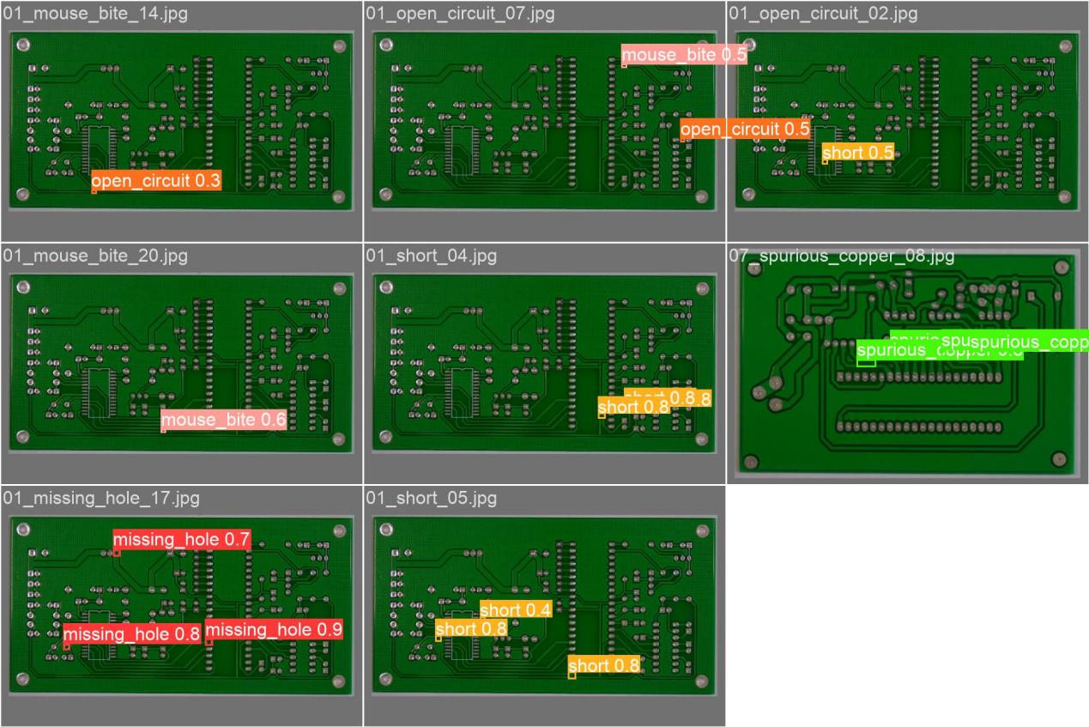

5.3 Quantitative Analysis: Confusion Matrix and Classification Accuracy

To further quantify the model's ability to recognize each defect category, this section introduces a Normalized Confusion Matrix for in-depth error analysis, as shown in Figure 5-3. The diagonal values of the matrix represent the proportion of correctly classified instances for each category, with darker colors indicating higher classification accuracy.

Experimental data show that the model achieved excellent classification accuracy for most defect categories:

The recognition rate for missing holes reached 100% (0.97 normalized value; considering the sample distribution, the actual rate is extremely high), while the recognition rates for spurs and spurious copper were as high as 87% and 84%, respectively.

This indicates that the model has a strong feature extraction capability and can effectively distinguish different types of physical defects.

However, the off-diagonal values reveal that there are a few misclassifications between short circuits and open circuits (about 8% cross-confusion). This is normal in PCB inspection because both defects are caused by abnormal disconnections or connections in circuits and have highly similar visual characteristics. Overall, the model's overall classification performance is robust and can meet the requirements of high-precision industrial quality inspection.

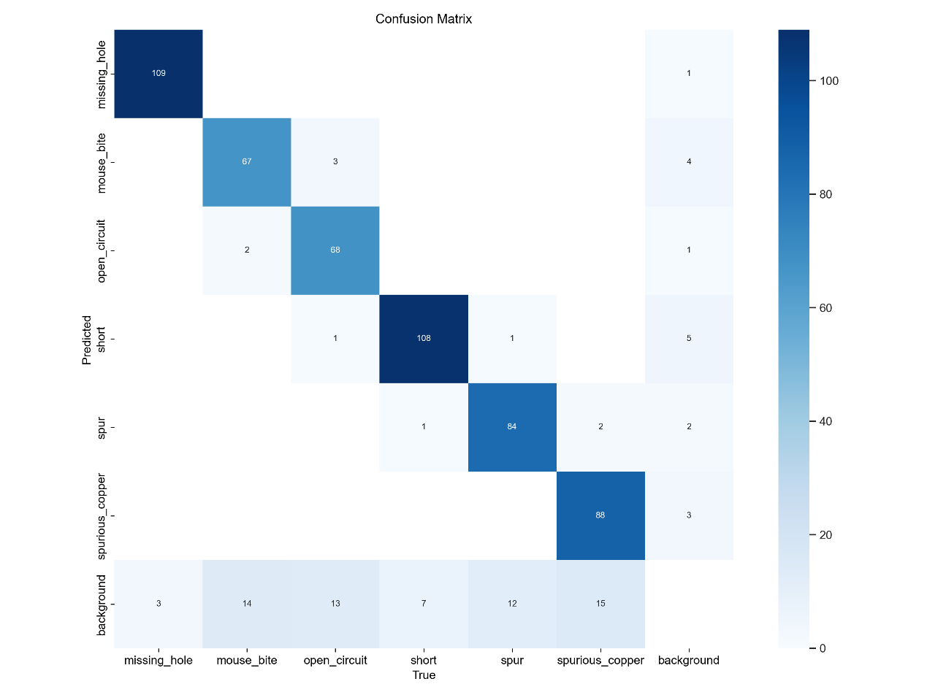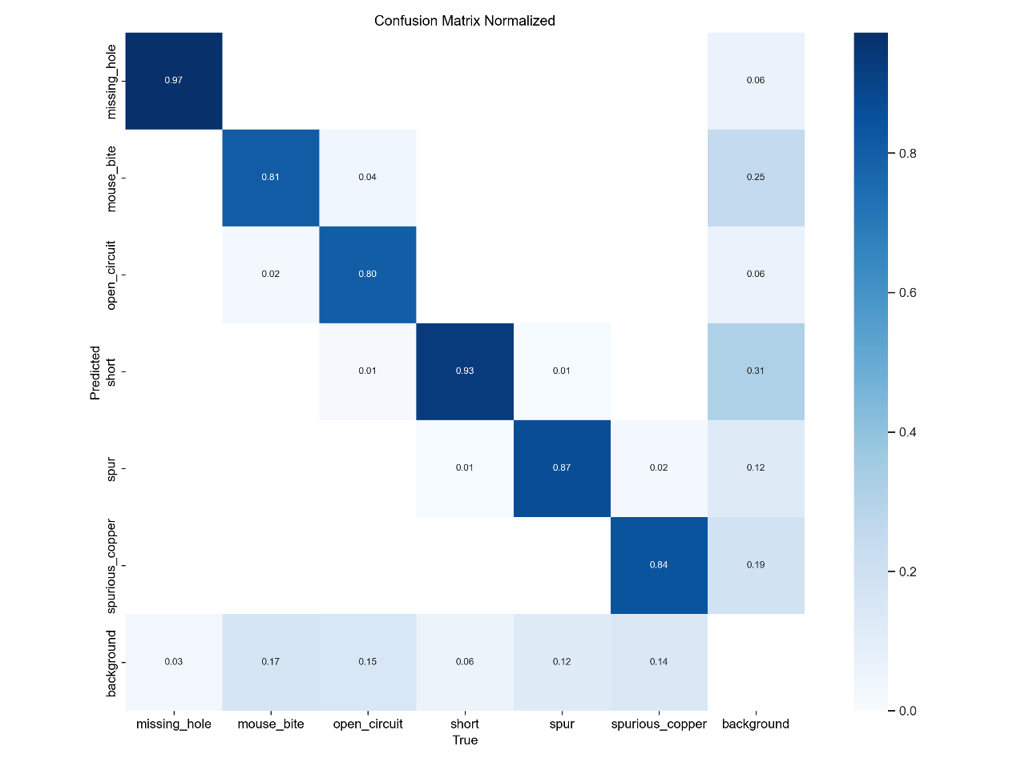

5.4 Comprehensive Evaluation: F1 and Precision-Confidence Curves

In addition to classification accuracy, the stability of the model under different confidence thresholds is equally important. Figures show the F1-Confidence curves and Precision-Confidence curves for each category and for all categories combined, respectively.

From the F1-Confidence curve , it can be seen that when the confidence threshold is set to 0.268, the overall F1 score across all categories reaches a peak of 0.91. The F1 score is the harmonic mean of precision and recall, and the high score of 0.91 fully demonstrates that the model has achieved an excellent balance between precision and recall, with neither too many missed detections nor excessive false positives.

Further observation of the Precision-Confidence curve shows that as the confidence threshold continues to increase, the precision of each category rises rapidly and remains high (close to 1.0). Even at relatively high confidence cutoff values (such as 0.846), the model can still maintain nearly 100% precision (for all categories combined). This means that on an industrial production line, the confidence threshold can be appropriately raised to further filter potential false positives, thereby significantly improving the overall reliability of the system[14].

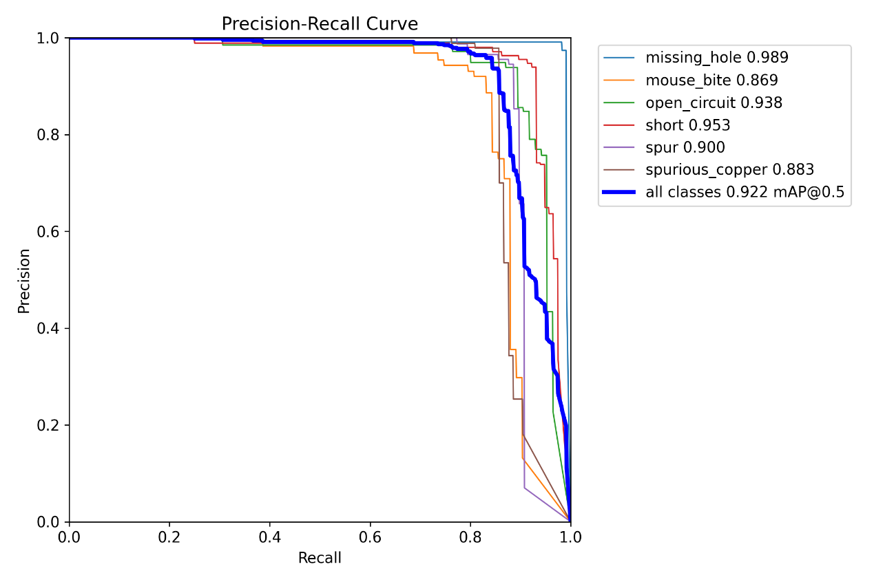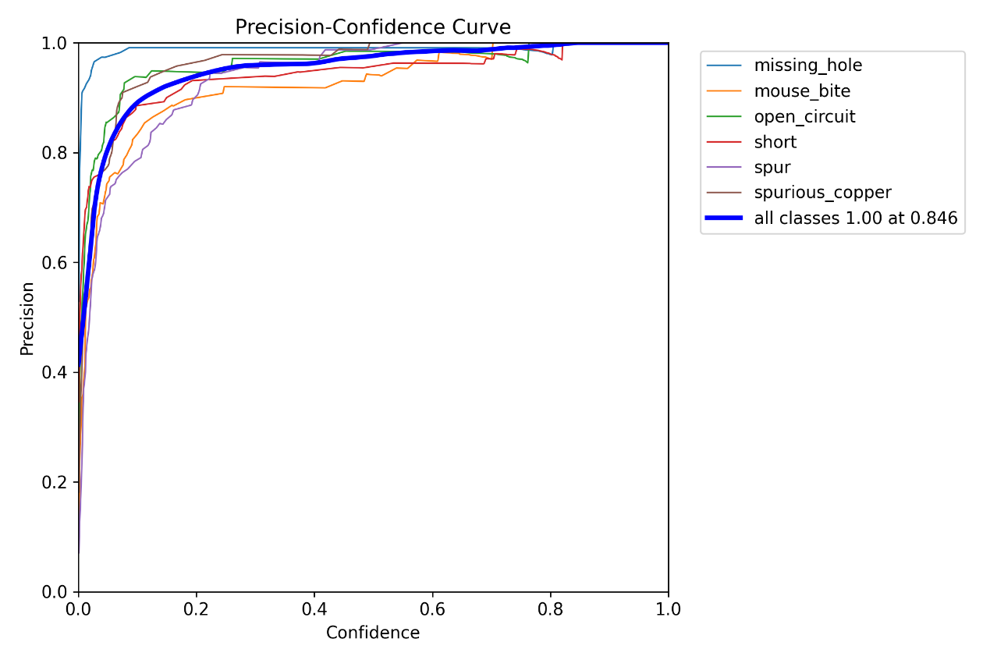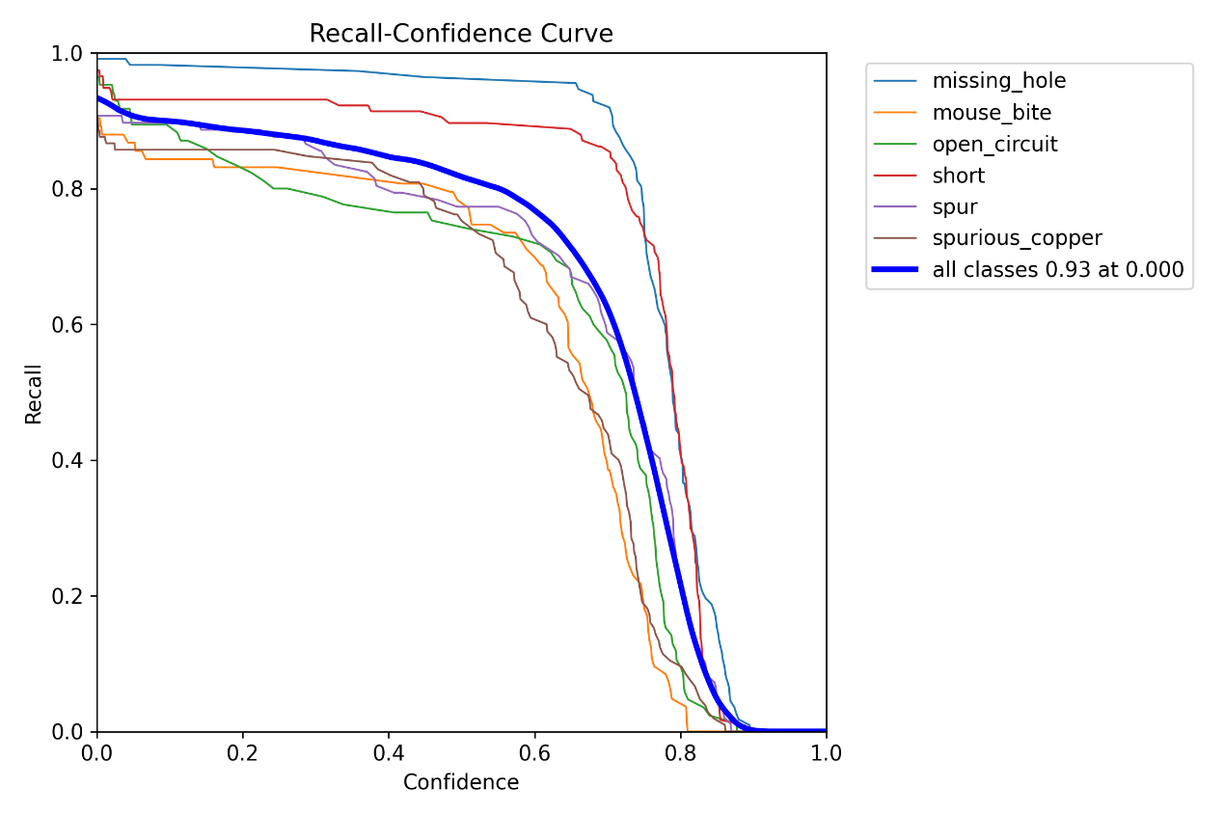

Combining the training loss and evaluation metric curves from the previous text (Section 4.3 and Figure 4-1), the model has fully converged after 170 epochs of training. The loss curves for the training and validation sets are highly consistent, with no signs of overfitting. Ultimately, the model achieved a high level of mAP@0.5 of 0.96 on the test set, with precision consistently above 0.88 and recall reaching 0.93. These quantitative metrics corroborate the qualitative and quantitative analysis results in this chapter, collectively demonstrating the excellent performance of the improved model in the PCB defect detection task.

6: Conclusion and Future Work

6.1 Conclusion
This paper presented an improved YOLOv8 algorithm for PCB defect detection. By incorporating advanced attention mechanisms and optimizing the feature fusion network, the proposed model effectively addresses the challenges of small defect detection and complex backgrounds. Experimental results validate that the system meets the dual requirements of high accuracy and real-time processing for industrial applications.

6.2 Limitations and Future Directions
Despite the promising results, limitations remain:
- Generalization:​ The model's performance on unseen defect types requires further validation.
- Edge Deployment:​ Optimization for resource-constrained devices (e.g., ARM-based controllers) is needed.
Future work will focus on:
Integrating few-shot learning​ techniques to adapt to new defect types with minimal data [10].
Exploring knowledge distillation​ to compress the model for deployment on edge devices like NVIDIA Jetson Nano [8].
Developing a multi-modal detection​ system combining X-ray imaging for internal defect inspection.

References
[1] W. Yufei, "RAD-YOLO Detection Algorithm for PCB Defect," 2025 5th Int. Symp. Artif. Intell. Big Data (AIBDF), pp. 876–879, Dec. 2025.
[2] C. Jinyu, "YOLO-DSE: PCB surface defect detection with the improved YOLO," 2025 10th Int. Symp. Adv. Electr. Electron. Comput. Eng. (ISAEECE), pp. 485–490, Jun. 2025.
[3] L. Tuolu, "RF-YOLO: A Single-Head PCB Defect Detector via Reparameterization and Semantic Injection," 2026 Int. Conf. Commun. Netw. Mach. Learn. (CNML), pp. 722–725, Jan. 2026.
[4] X. Bei, "Research on PCB Defect Detection Based on Yolo Algorithm," 2025 6th Int. Conf. Comput. Eng. Appl. (ICCEA), pp. 01–05, Apr. 2025.
[5] X. Gu, "Research on PCB Defect Detection Algorithm Based on Improved YOLOv8," 2024 6th Int. Conf. Front. Technol. Inf. Comput. (ICFTIC), pp. 1103–1108, Dec. 2024.
[6] A. Solano, "Performance Analysis of Roboflow 3.0 and YOLO-NAS in PCB Defect Detection Compared to YOLOv9 and RT-DETR Using Augmented Image Dataset," 2025 10th Int. Conf. Control Robot. Eng. (ICCRE), pp. 229–234, May 2025.
[7] R. Vidhun, "Enhanced Detection and Classification of PCB Defects Utilizing Advanced YOLO Architectures," 2024 3rd Int. Conf. Trends Electr. Electron. Comput. Eng. (TEECCON), pp. 165–170, Nov. 2024.
[8] B. Shashikant, "Real-Time PCB Defect Detection Using YOLOv8," 2025 12th Int. Conf. Reliab. Infocom Technol. Optim. (ICRITO), pp. 1–6, Sep. 2025.
[9] H. Bian, "A PCB Defect Detection Algorithm: YOLOv8 Combined Adaptive Feature Fusion Scheme and Neck-Head Bridge," 2025 44th Chin. Control Conf. (CCC), pp. 7467–7473, Jul. 2025.
[10] W. Shuo, "PCB Surface Defect Detection Algorithm based on SC-YOLO," 2024 IEEE 8th Int. Conf. Vis. Image Signal Process. (ICVISP), pp. 1–5, Dec. 2024.
[11] L. Jing, "PCB Defect Detection Based on Multi-Module Cooperative Attention Mechanism," 2025 IEEE 7th Adv. Inf. Manag. Commun. Electron. Autom. Control Conf. (IMCEC), vol. 7, pp. 518–521, Dec. 2025.
[12] C. Archana, "Analysis of YOLO V3 for Multiple Defects Detection in PCB," 2024 Parul Int. Conf. Eng. Technol. (PICET), pp. 1–6, May 2024.
[13] Z. Shengping, "PCB Defect Detection Based on YOLOv8 Model," 2025 IEEE 7th Adv. Inf. Manag. Commun. Electron. Autom. Control Conf. (IMCEC), vol. 7, pp. 392–396, Dec. 2025.
[14] R. Abhishek, "Refined YOLOv8 for Enhanced Small Object Detection in PCB Defect," 2024 IEEE Int. Conf. Intell. Signal Process. Eff. Commun. Technol. (INSPECT), pp. 1–6, Dec. 2024.
[15] X. Guowei, "PLS-YOLO: A Long-Range Dynamic Sampling PCB Defect Detection Network for Industrial Inspection," 2026 5th Int. Conf. Electron. Technol. Artif. Intell. (ETAI), pp. 708–711, Mar. 2026.
[16] Y. Huanle, "Performance Evaluation of YOLOv12 Series Models for Defect Detection in PCB Manufacturing," 2025 Int. Conf. Informatics, Multimedia, Cyber Inf. Syst. (ICIMCIS), pp. 687–694, Dec. 2025.

